 | Filing Reference : |  | GG/COMS/TS.2/11
 | Document Title : |  | Use-Case Realization Report (Analysis)  Manage Sales Order
 | Version : |  | 1.0
 | Prepared By : |  | Koh Ming Jin
 | Date Created : |  | Monday, Jul 15th, 2011
Approved By :
 |  | Tran Ba Tien |  | Date
 |  | Project Manager |  | 15th Jul 2011
©2011 [Hoang Kim joint stock Company].
The information contained in this document is the property of [Hoang Kim joint stock Company]. The contents must not be reproduced, wholly or in part, for purposes other than for which it has been supplied, without the prior permission of [Hoang Kim joint stock Company], or, if it has been furnished under contract to another party, as expressly authorised under that contract. [Hoang Kim joint stock Company] shall not be liable for any errors or omissions.

Revision History
Date | Version | Description | Author
15/Jul/2011 | 1.0 | Initial Document | Koh Ming Jin

Table of Contents
1. Brief Description 4
2. Flow of Events 4
2.1 Standard Flow 4
2.1.1 Log-In 4
2.1.2 User Functions 4
2.1.3 Creation of Sales Order 4
2.1.4 Update Sales Order 4
2.1.5 Delete Sales Order 4
2.1.6 Log-Out 5
2.2 Exception 5
3. Interaction Diagrams 5
3.1 Collaboration Diagram for Manage Sales Order 5
4. Participating Objects 6
4.1 Main Page 6
4.2 Main Controller 6
4.3 Sales Order Controller 6
4.4 Cylinder Controller 7
4.5 Sales Order 7
4.6 Sales Order Detail 7
4.7 Cylinder 7
5. Class Diagrams 7
5.1 Domain Class Diagram: Manage Sales Order 7
6. Derived Requirements 8

Use-Case Realization Report
Manage Sales Order

Brief Description
This use case enables a Sales Staff to manage Sales Order records. Managing Sales Order records includes creating, updating and deleting of Sales Order records. The required information includes the Sales Order ID, Sales Order number, ordered items information and Sales Order customer information.

Flow of Events
The standard flow of events for this use case and any exceptions are described in the following subsections. See section 3.1 for an overview of the participating Actors and Domain Objects.

Standard Flow
The flow of events is described as follows:

Log-In
To commence using the system, the Operation Manager is required to log-in successfully as follows:
- Refer to Log In Use Case for details.

User Functions
- The use case starts when the authenticated Sales staff selects the Manage Sales Order option of the MainPage. This will redirect the Sales staff to the RoleMainPage

Creation of Sales Order
- The Sales Staff provides all the required details (e.g. Cylinder order & Customer information) concerning a new Sales Order into the RoleMainPage (operation enterSalesOrderInfo).
- The Sales Order will be submitted (operation createSalesOrder) to the MainController using the operation createSalesOrder of MainController.
- The MainController will pass the information to the SalesOrderController using operation createSalesOrder.
- The SalesOrderController will insert the information into SalesOrderDetail (operation insert), create the Sales Order (operation create) and create the cylinders using the operation create of CylinderController and Cylinder object.
- The use case terminates.

Update Sales Order
- The Sales Staff will view a particular Sales Order (step 1-5) (refer to view Sales Order use case).
- The Sales Staff will delete and submit (operation deleteSpecificOrder) to the MainController using the operation deleteSpecificOrder of MainController.
- The MainController will pass the information to the SalesOrderController using operation updateSalesOrder.
- The SalesOrderController will update the information into SalesOrderDetail (operation update).
- The use case terminates.

Delete Sales Order
- The Sales Staff will view a particular Sales Order (step 1-5) (refer to view Sales Order use case).
- The Sales Staff will update the details (e.g. Cylinder orders) concerning the selected Sales Order.
- The Sales Order will be submitted (operation updateParticularSalesOrder) to the MainController using the operation updateParticularSalesOrder of MainController.
- The MainController will pass the information to the SalesOrderController using operation deleteSpecificOrder.
- The SalesOrderController will delete the information in SalesOrderDetail object (operation update).
- The RoleMainPage will refresh to display the deletion operation result.
- The use case terminates.

Log-Out
- The Operation Manager will terminate use of COMS (ie: log-out) by pressing a button with the caption “Log Out”.
- Refer to the Log Out Use Case for details.

Exception
- The Sales Order ID does not exist for update or delete option. If the input Sales Order ID is not found to be an existing one, the Sales Order modification or deletion will fail. An error message will be displayed, and subsequently redirect to the Manage Sales Order Page.

Interaction Diagrams

Collaboration Diagram for Manage Sales Order

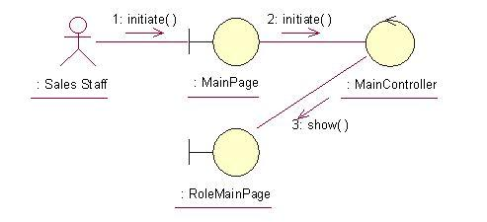
The above collaboration diagram shows the process flow after the actor has login.

Create Sales Order

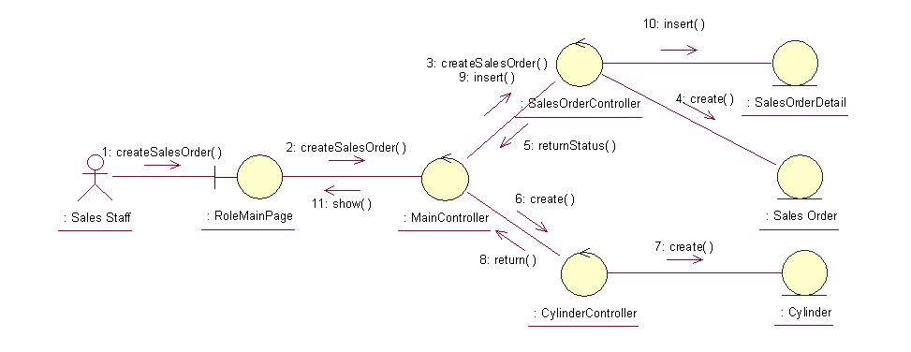

Update Sales Order

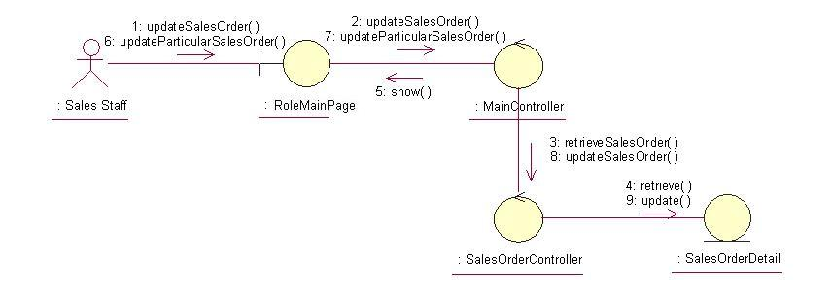

Delete Sales Order
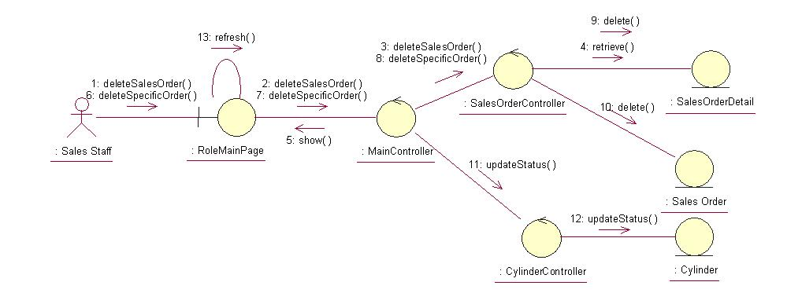
The above collaboration diagrams show the main process flows of this use case.

Participating Objects

Main Page
This object renders the contents after the actor has login. The Director, Department Manager and Operation Manager actors use this object.

Role Main Page
This object renders the contents (based on the user role) after the actor has login. The Sales staff uses this object.

Main Controller
This object acts as the middleman between Main Page and the Sales Order Controller. It will translate interactions with the view into actions to be performed by the Sales Order Controller.

Sales Order Controller
This object acts as the middleman between related Sales Order Pages and the Sales Order and Sales Order Detail objects. It will translate interactions with the view into actions to be performed by the Sales Order or Sales Order Detail objects.

Cylinder Controller
This object acts as the middleman between Sales Order Controller and the Cylinder object. It will translate interactions with the view into actions to be performed by the Cylinder object.

Sales Order
This object stores the details concerning the Sales Order of the COMS.

Sales Order Detail
This object stores the details concerning the Sales Order Detail of the COMS.

Cylinder
This object stores the details concerning the Cylinder of the COMS.

Class Diagrams

Domain Class Diagram: Manage Sales Order

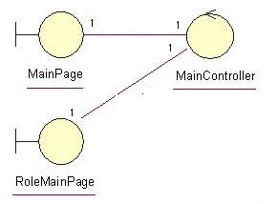
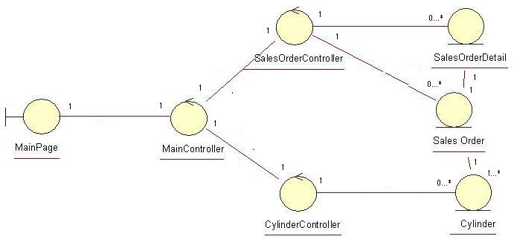

Derived Requirements
The Sales Staff PC keyboard and mouse will be used to enter Sales Order details (if any) and view all the system responses.

